**New mixed-bed resin from LANXESS for ultra-pure water in semiconductor production**

* **Lewatit UltraPure 1296 MD PLUS now available**
* **Significant reduction in metal content of ion exchange resin components**
* **Minimal release of TOCs (Total Organic Carbon) and particles**
* **High operating capacity**

**Shanghia, October 10, 2023** – Specialty chemicals company LANXESS has developed a new mixed-bed resin for ultra-pure water in semiconductor production. In comparison with the established Lewatit UltraPure 1296 MD mixed bed, the new UltraPure 1296 MD PLUS boasts a much lower content of metals such as iron, zinc and sodium. Early installations of the product as a final polishing filter in semiconductor manufacturing have yielded results close to the current analytical limits of detection.

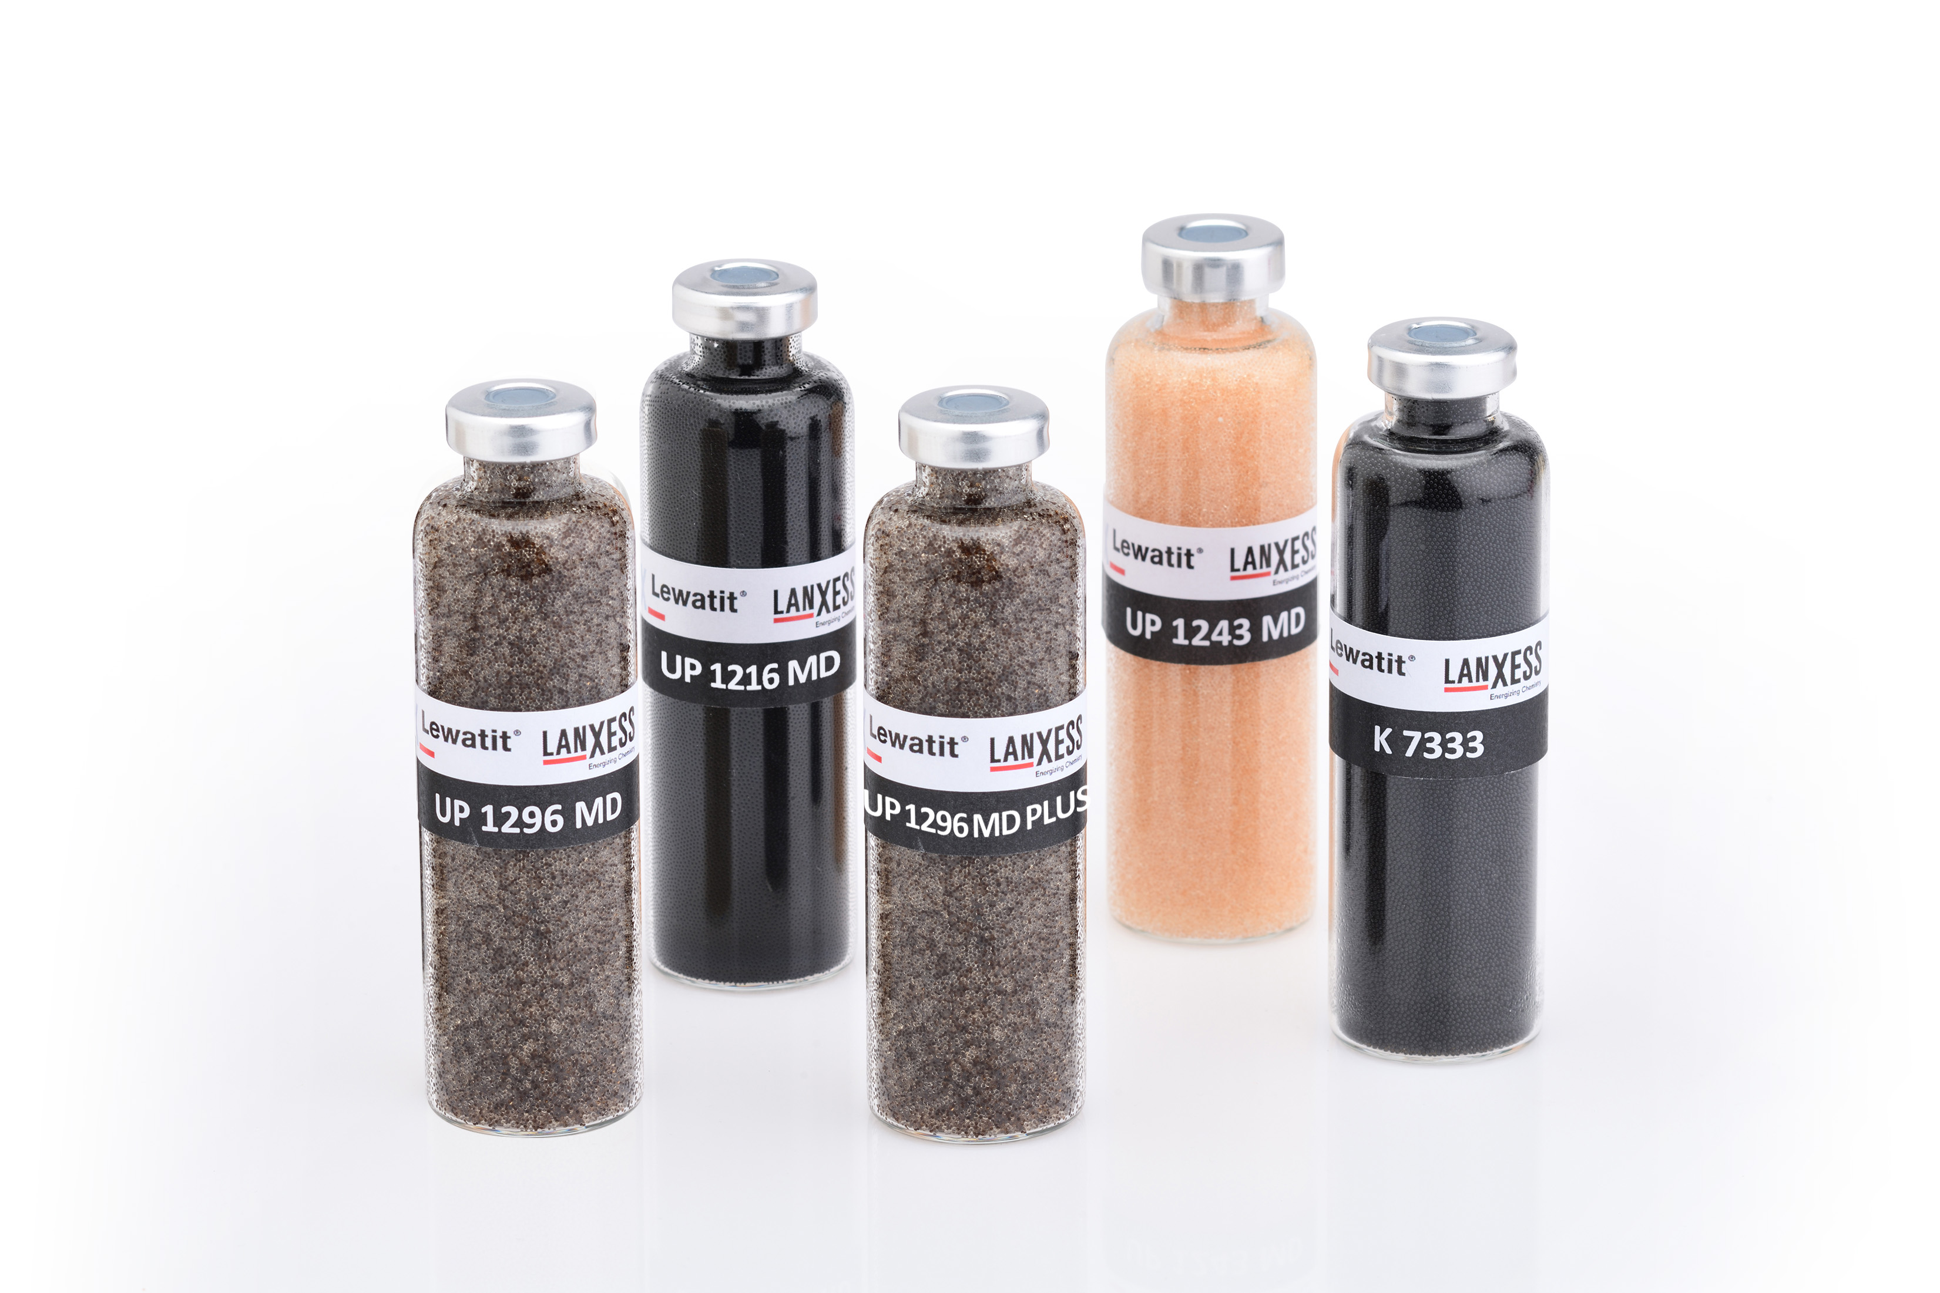

LANXESS will be unveiling its new type of ion exchange resin to trade visitors at the UltraPure Micro conference being held in Austin in the US state of Texas from October 10 to 12, 2023.

“The Lewatit UltraPure 1296 MD PLUS produced in Germany is a vital component for cost-effective, sustainable and fault-free manufacturing in the fast-growing international semiconductor industry,” says Hans-Juergen Wedemeyer, Technical Marketing Manager at the Liquid Purification Technologies business unit at LANXESS.

**Lewatit UltraPure 1296 MD PLUS for the toughest assignments**

The manufacturing of semiconductors and displays calls for complex water treatment to ensure that the water used is of the required purity. The latest generation of wafers and microchips demands a correspondingly high level of quality from the ion exchange resin systems employed. Furthermore, new analytical systems are capable of analyzing ions in the low ppt (parts per trillion) range. For some types of ion, they can go as low as the ppq (parts per quadrillion) range. Achieving the performance of semiconductors required by modern industry can necessitate as many as 200 treatment steps. The ultra-pure water needed for this is provided by means of a complex multi-stage process. The most important steps in the operation include conventional primary demineralization with standard ion exchange resins, reverse osmosis, degasification, ultrafiltration and hydrogen peroxide removal, while the last stage is final polishing with an ultra-pure mixed bed. The new Lewatit UltraPure 1296 MD PLUS ion exchange resin type was developed specifically for this final step, which is absolutely critical to the success of the process as a whole.

The ultra-pure water treated in this way can then be used in etching and cleaning processes in microchip production. “The high total capacity and degree of regeneration of the anion and cation exchange resins also result in excellent operating capacity for the removal of boron and silica, as well as metal ions,” says Wedemeyer.

“The bead sizes of the monodisperse components are designed to avoid an inadvertent separation of cation and anion exchange resins. Due to the special production process for Lewatit UltraPure 1296 MD PLUS, the release of particles and TOC- is within an extremely low range,” adds Wedemeyer.

You can find more detailed information about products from the Liquid Purification Technologies business unit on the website at [www.lewatit.com](http://www.lewatit.com).

**About LANXESS**

LANXESS is a leading specialty chemicals company with sales of EUR 8.1 billion in 2022. The company currently has about 13,100 employees in 32 countries. The core business of LANXESS is the development, manufacturing and marketing of chemical intermediates, additives and consumer protection products. LANXESS is listed in the leading sustainability indices Dow Jones Sustainability Index (DJSI World and Europe).

**LANXESS China**

On January 31, 2005, the company was initially listed on the Frankfurt Stock Exchange and LANXESS Chemical (China) Co., Ltd. officially started operations. LANXESS now has 13 subsidiaries, 5 R&D centers and 5 production sites in Greater China. LANXESS works closely with its local partners to develop market-oriented solutions that meet local market needs.

**Forward-Looking Statements**

This company release contains certain forward-looking statements, including assumptions, opinions, expectations and views of the company or cited from third party sources. Various known and unknown risks, uncertainties and other factors could cause the actual results, financial position, development or performance of LANXESS AG to differ materially from the estimations expressed or implied herein. LANXESS AG does not guarantee that the assumptions underlying such forward-looking statements are free from errors, nor does it accept any responsibility for the future accuracy of the opinions expressed in this presentation or the actual occurrence of the forecast developments. No representation or warranty (expressed or implied) is made as to, and no reliance should be placed on, any information, estimates, targets and opinions, contained herein, and no liability whatsoever is accepted as to any errors, omissions or misstatements contained herein, and accordingly, no representative of LANXESS AG or any of its affiliated companies or any of such person's officers, directors or employees accept any liability whatsoever arising directly or indirectly from the use of this document.

**Information for editors:**

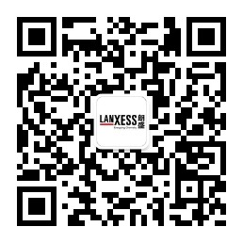All LANXESS news releases and accompanying photo, video and audio materials can be found at http://www.lanxess.cn, http://www.weibo.com/lanxess, or LANXESS' official WeChat account: lanxess_china (QR code provided below)