**LANXESS China Recognized as Top Employer China for the Seventh Consecutive Year**

**Shanghai, January 19, 2024** - Specialty chemicals company LANXESS has once again been recognized as one of China's Top Employers 2024, marking the seventh consecutive year that the company has been awarded this prestigious recognition by the Top Employers Research Institute.

“Being consistently honored as one of China's Top Employers is the best recognition of LANXESS' long-term development in China,” Michael Rockel, CEO of LANXESS Greater China, said. “Talent is pivotal in business growth, and amidst a complex and uncertain external environment, motivated employees will help companies traverse cycles and lay a solid foundation for resilient growth. LANXESS is steadfast in its dedication to ensuring employee motivation through comprehensive care and supporting their sustainable career paths.”

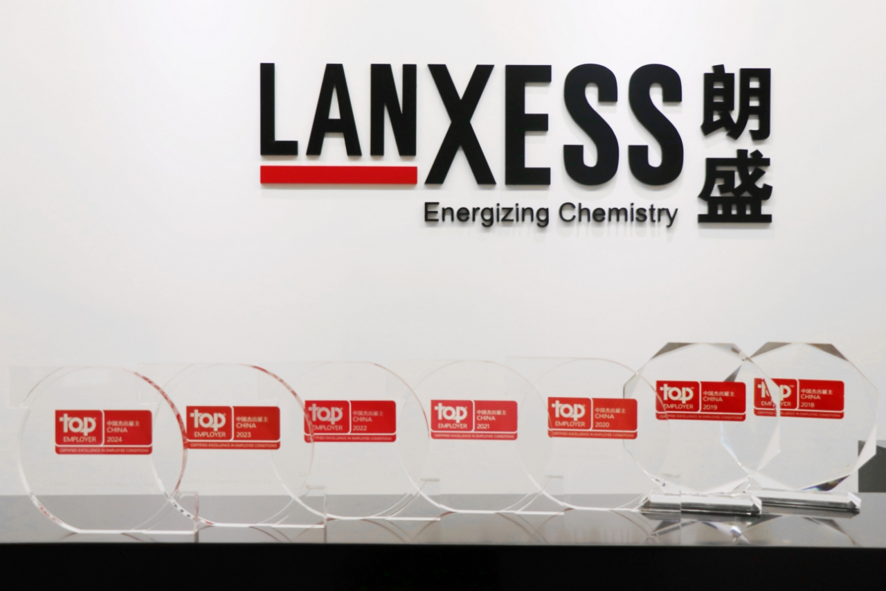

**LANXESS Employee Assistance Program: Addressing Work-Life Challenges Effectively**

The past three years have seen a significant impact on global mental health due to the ongoing epidemic. In 2020, global reports indicated a staggering 26% increase in depression and a 28% rise in anxiety disorders. To address these challenges, LANXESS launched a specialized Employee Assistance Program (EAP) this year. The program focuses on aiding employees and their families in identifying and effectively managing various work-related challenges, thereby enhancing their overall well-being.

As an all-encompassing program, LANXESS recognizes the importance of employee mental health and family harmony in improving work efficiency and quality of life. The Employee Assistance Program is designed to assist employees in handling workplace stressors like interpersonal relationships, and career development. Additionally, it aims to support employees in managing personal life challenges encompassing health, family, marriage, and emotional stress. The program aims for a harmonious work-life balance by offering mental health counseling and family support services.

The program has set up a 24-hour counseling hotline accessible to all employees and immediate family members. Professional counselors provide effective solutions for emotional stress caused by issues in the psychological, physical, legal and financial areas through phone, video, or face-to-face counseling sessions.

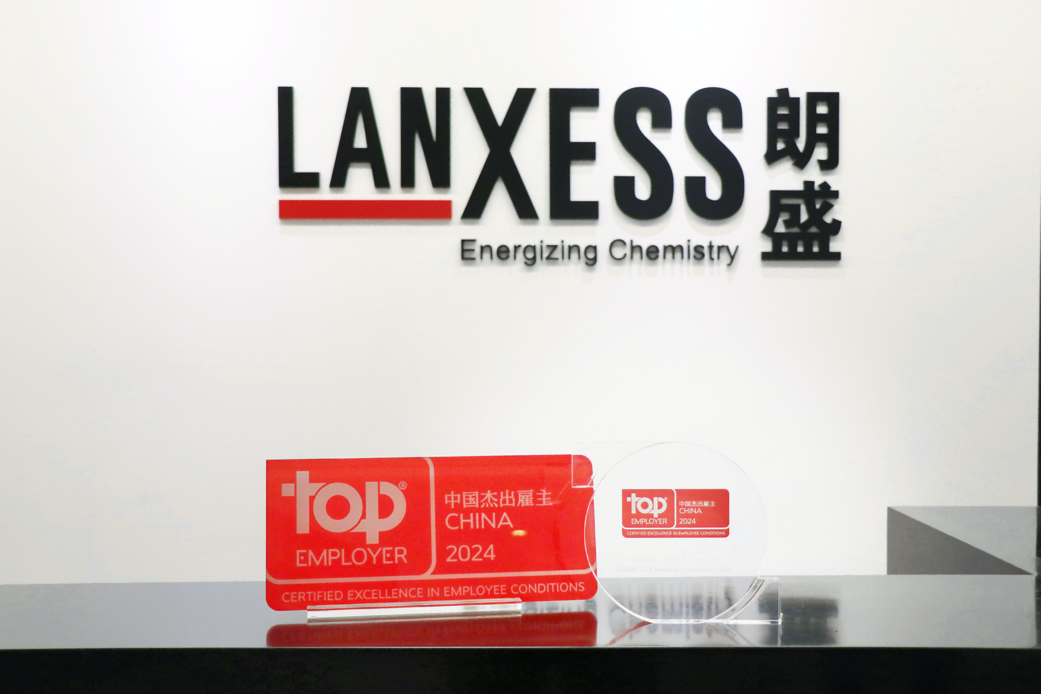

**Workplace Care: Nurturing Resilience and Professional Development**

As an awarded employer, LANXESS is dedicated to fostering an inclusive, respectful and caring workplace environment, and the EAP program also aims to train managers to enhance healthy leadership, improve management's ability to recognize their own and their team members' emotions and stress levels, and contribute to effective communication and healthy team development. In order to support employees' career development, the company also provides a variety of learning and growth opportunities, including professional skills training and career planning, to ensure that employees can continue to grow in their career paths.

Moving forward, LANXESS remains committed to optimizing the work environment and development opportunities for its employees. The company aims to establish a significant advantage for long-term sustainable growth by aligning social value, employee welfare, and corporate success.

**About LANXESS**

LANXESS is a leading specialty chemicals company with sales of EUR 8.1 billion in 2022. The company currently has about 13,000 employees in 32 countries. The core business of LANXESS is the development, manufacturing and marketing of chemical intermediates, additives and consumer protection products. LANXESS is listed in the leading sustainability indices Dow Jones Sustainability Index (DJSI World and Europe).

**LANXESS China**

On January 31, 2005, the company was initially listed on the Frankfurt Stock Exchange and LANXESS Chemical (China) Co., Ltd. officially started operations. LANXESS now has 13 subsidiaries, 5 R&D centers and 5 production sites in Greater China. LANXESS works closely with its local partners to develop market-oriented solutions that meet local market needs.

**Forward-Looking Statements**

This company release contains certain forward-looking statements, including assumptions, opinions, expectations and views of the company or cited from third party sources. Various known and unknown risks, uncertainties and other factors could cause the actual results, financial position, development or performance of LANXESS AG to differ materially from the estimations expressed or implied herein. LANXESS AG does not guarantee that the assumptions underlying such forward-looking statements are free from errors, nor does it accept any responsibility for the future accuracy of the opinions expressed in this presentation or the actual occurrence of the forecast developments. No representation or warranty (expressed or implied) is made as to, and no reliance should be placed on, any information, estimates, targets and opinions, contained herein, and no liability whatsoever is accepted as to any errors, omissions or misstatements contained herein, and accordingly, no representative of LANXESS AG or any of its affiliated companies or any of such person's officers, directors or employees accept any liability whatsoever arising directly or indirectly from the use of this document.

**Information for editors:**

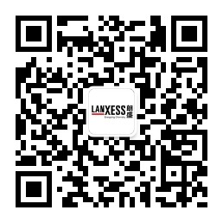All LANXESS news releases and accompanying photo, video and audio materials can be found at http://www.lanxess.cn, http://www.weibo.com/lanxess, or LANXESS' official WeChat account: lanxess_china (QR code provided below)